Ramadan 03/04/2024

Lesson 126 and 127

The Pitfalls Of A Centralized Workflow

<https://www.canva.com/design/DAEP32iZwVc/e8vtEkcNNATEdm3_lPKU0A/view>

He mistakenly wreck the master branch

Lesson 128

Centralized Workflow Demonstration

go to setting of the repo, under collaborator invite the person

Watch the Adding Collaborators. Note before you go further

Dev account below

Don below

**Dev** below

<https://getbootstrap.com/docs/5.0/getting-started/introduction/>

I got bootstrapped boiler plate from the link above

**Dev** want to pull down those changes

I pull down on dev here

<https://getbootstrap.com/docs/4.0/components/forms/>

Now I need a login form the link is above on Abeythedon below is don page

This don

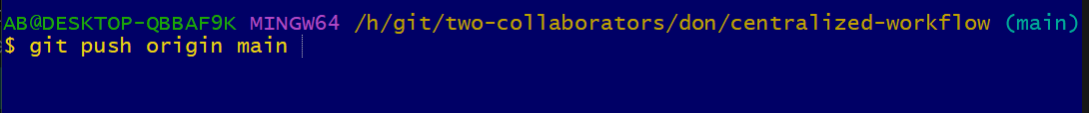

On dev below I want to make Navbar

<https://getbootstrap.com/docs/4.0/components/navbar/>

This is dev

He needs to send it to github

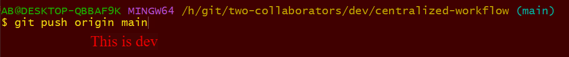

I don’t have all the new work from github and git wont allow me to do that.

Don push that to github and dev does not have that locally



He has changes that He’s not readly to commit and He needs to attend to dev



Ramadan Friday 5/04/2024

Lesson 129

The All-Important Feature Branch Workflow

Don’t work on master branch.

**He** pushes that feature branch to github why Master is left untouch.

She does not need to share her animated-scroll yet but she can pull add-dark-theme work down.

